WIRELESS OPTIMIZATION

Group-23

Final Report



Group Members

Akhil Eluguri (20118560)

Siri Chandana Karra (19872665)

Krishna Shashank (19168682)

Vijay Kiran Gollapudi (19183537)

Table of contents:

1. INTRODUCTION 3
2. PROJECT GOAL 3
3. PROJECT PLAN 3
4. PROJECT SCOPE 4
5. PROJECT TEAM MEMBERS 4
6. PHYSICAL SITE SURVEY 5
7. POSITION OF ACCESS POINTS 5
8. SITE SURVEY TOOLS RESEARCH 10
9. ACTUAL SITE SURVEY USING TOOLS 11

LEVEL-1

LEVEL-2

LEVEL-3

LEVEL-4

1. PROBLEMS AND PROPOSED SOLUTIONS 26
2. BUILDING MATERIALS 29
3. COSTING 30
4. CONCLUSION 30
5. REFERENCES

**1. Introduction:**

The necessity of wireless devices is rapidly increasing day by day based on the requirements of the users. The reliability of wireless platform is also increasing due to communication glitches that are occurring in wired media. Although many users in the world (both individual and corporate) are relying on the wireless networks there are many challenges that every user face with these networks. These challenges and issues are needed to be fulfilled and it is necessary to provide a smooth and effective quality of network to the user by means of communication. Restricting the number of users connected to a network is seemingly impossible, rather providing alternative wireless systems is the basic motto of this project.

**2. Project goal**

The main goal of this project is to improve the signal strength by considering the current network which will overcome the issues regulated while doing the survey. By increasing the throughput to certain level where the signal strength is not up to the expected range. So that, we can reach the maximum threshold value without any interference.

**3. Project plan**

**Description**

According to some network surveys it is observed that the peak time for the users to connect to their networks is from 7 pm to 10 pm. Based on requirement of this project it is mentioned that, a user handles minimum of two devices. Also it important to give a assurance to the users who are connected to the network by satisfying their requirements on the time and also helping them in understanding and learning about the signal strength at different locations wherever the network is connected.

**Effort/Duration expected**

Main goal of this project is that the performance of the wireless devices should be perfect according to the needs of the users. There might be many challenges in obtaining the end results as each wireless device has various specifications. Their impact on the wireless network is depended on their functionality profile. Regarding the wireless devices, several physical parameters like gain, frequency, bandwidth etc., are calculated and the readings which are close to or exactly matching the actual readings are determined.

Then physical surveying of the users who are connected to the network is performed along with identifying the structure and demographics of the building. All the information parameters are gathered and then prioritized according to the project which is performed in weekly scrum meetings and necessary omitting can be done.

Assumptions from the given project structure and the tasks that are to be performed, the project is subjected to take a minimum of 7 to 8 weeks. Also, proper measures and appropriate alternatives should be considered when there may be rise in issues regarding the project deliverables.

**4. Project Scope**

The main aim is to provide better quality of network with uninterrupted browsing data, provide the network security when the users try to share the data and delivering better quality of internet during peak time. There are many concerns regarding the wireless networks that are to be concentrated when delivering better quality of network. Such as delivering better systems and check whether the devices are tuned perfectly or not, and also developing model infrastructures for better understanding of the wireless networks.

**5. Project Team Members**

|  |  |  |  |
| --- | --- | --- | --- |
| Name | Student ID | Responsibilities | |
| Site Survey | Documentation |
| Akhil Eluguri | 20118560 | Level-1,2 | 1,2,3,4 Deliverables, Mid-term report, Final documentation |
| Siri Chandana Karra | 19872665 | Level- 3,4 | 1,2,3,4 Deliverables, Mid-term report, Final documentation |
| Krishna Shashank | 19168682 | Level- 3,4 | 1,2,3,4 Deliverables, Mid-term report, Final documentation |
| Vijay Kumar Gollapudi | 19183537 | Level- 1,2 | 1,2,3,4 Deliverables, Mid-term report, Final documentation |

**6. Physical Site Survey**

We were allotted to Physical Science – 1 block, which consists of four levels in which the survey has to be done. We were provided with the floor maps of all the levels in the block which we are allowed to do the survey. All four of us have done a physical site survey at all levels. According to the survey which we have done across all levels we found 19 AP’s in different levels at different positions.

**7. Position of Access Points**

In level – 1 of PhysicalSciences-1 we are having rooms from 101- 121. In this level we found two AP’s one is located at the exit i.e., AP-147 and the other is at AP-137 which is near to room 106.

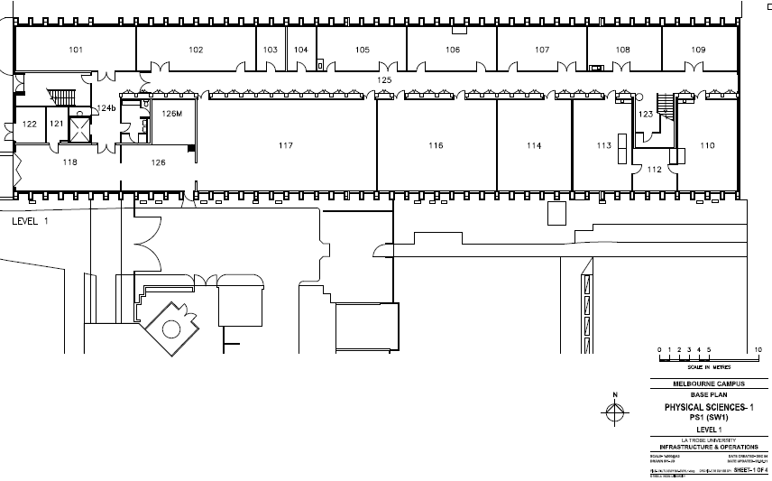

In level – 2 of PhysicalSciences-1, we are having rooms starting from 201-227. We found five AP’s at different locations in this level which are:

* 1 AP – L11 near PS1-201
* 1 AP – 139 near PS1-207
* 1 AP – 140 near PS1-226
* 2 AP’s inside PS1 – 249

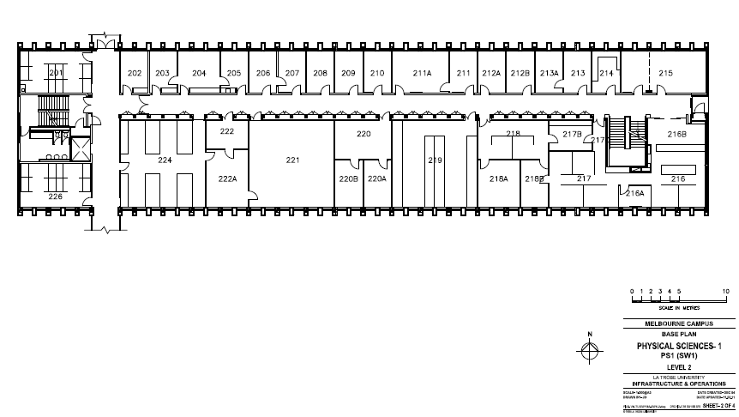

In level – 3 of Physical Science – 1, we are having rooms starting from 301-329. We found 9AP’s which are located in different locations on this floor which are:

* 1AP inside physics computer lab room -301
* 1AP – 142 near PS1-302 near to lift.
* 1AP – 143 near PS1-307
* 1AP inside physics lab room -314
* 1AP inside senior physical lab room -317
* 1AP inside senior physical lab room -319
* 2 AP’s inside physics lab room -321
* 1AP inside 1st-year physics lab room -327

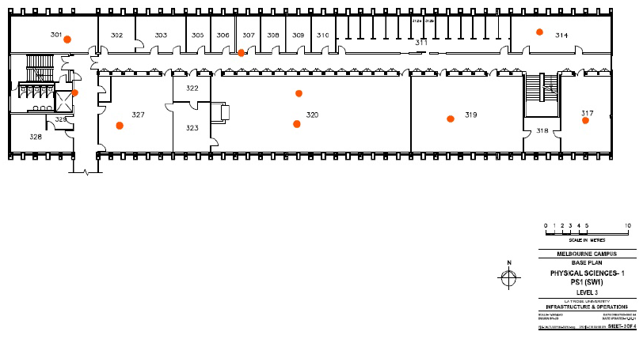

In level 1– 4 Physical Sciences -1we are having rooms from 401-432. There are 3AP’s in level 4, which are:

* AP – 146 near PS1-402
* AP – C10 near PS1-408
* AP – 145 near PS1-414

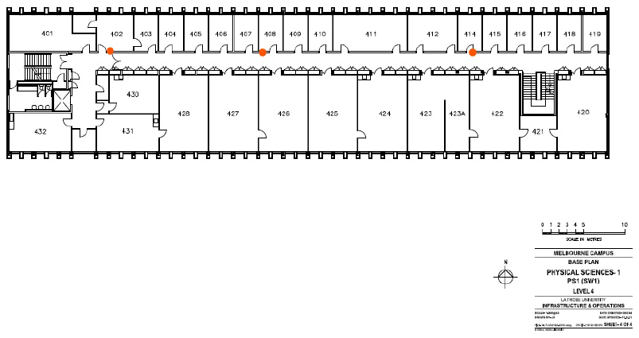

**Detail Survey of each Level:**

**Level 1:**

This level has two entries, and the roof is insulated with metallic surface.

Room 101 is the plant room which requires authorization to access. We don’t have access to that room. There are speakers in the room, which may cause interference.

Room 102 is an X-ray lab with laser products inside; rooms 117,118 are single labs with large iron metal equipment, which we don’t have access. Mostly no AP’s inside within our visibility.

Room 103 is physics uninterruptable power room with no AP’s inside. There is lots of sound coming from the room, lots of wiring, which may sometimes cause interference. Room 104 is a professor room.

Room 105 is an instrument fabrication room which has large chemicals stored metallic containers. It has no access, mostly no AP’s inside can’t see through.

Room 106 is an electronic beam lab with chemical lab equipment inside, which may cause interference. We can’t find any AP’s from outside the room.

Room 107 is an X-ray imaging lab, and room 108 is atomic scope microscopy lab, which consists of metallic equipment related to X-rays, and we can’t find any AP’s in here.

Room 109 is an atomic scale research lab with large equipment inside and has no access and no AP’s.

Room 110 is an X-ray photoelectron spectroscopy with large metallic equipment with no access inside. This metallic equipment may cause interference.

Room 113 is Sims lab which has huge metallic equipment with no access. Room 114 is vislab1 with no access we can’t see through from outside.

Room 115 & 116 are atomic-scale research lab with huge metallic equipment with no access.

From our survey, we observed that this level was the least populated level when compared to other levels of the building.

**Level 2:**

This roof of this level is same as like 1st floor, which is metallic surface. Most of the rooms in this level are professor rooms

Room 201 is an immersive interaction design lab. It’s an empty room and there are no access points inside the room which is clearly visible to us.

Room 202,215B and 221 are meeting rooms with no access to us. Room 204 is student room and there are no AP’s inside the room.

Rooms 203,205,206,207,208,209,210,211,212B, 213 are professor rooms and rooms 211A, 212A, 214 are staff rooms, and 214 have a kitchen which has microwave ovens and cause interferences.

Room 215 is a faculty office room, and rooms 216 & 218 are cybersecurity rooms with no access.

Room 219 is a Cisco lab which has two access points, **five switches,** and **33 computers** in it. Room 220 is SEMS research staff room.

Room 222 is a computer room with **11 switches** and **one fiber switch**.

Room 224 is CSIT project lab with **36 computers** in it.

Room 226 is an artificial intelligence, data science research lab with no access.

Room 227, just near the staircase, is a closed room which is locked.

**Level 3:**

Room 301 is a physical computer lab with one access point, and **15 pc’s** in it.

Rooms 302,305,306,308,309,310 and 322 are professor rooms.

Room 303 is department of chemistry & physics, and room 307 is physics research student room which has an access point near the room.

Rooms 311 & 314 are physics lab, which has **12 pc’s** and 1 AP inside, which are visible to us and has no access.

Room 317 is senior physics lab which has no access. It has one AP, and **nine pc’s** inside the room, and room 319 is also a senior physics lab with one AP, and **15 pc’s** inside.

Room 321 is physics lab with 2 AP’s and **40 pc** inside, which are visible to us.

Room 327 is 1st year physics lab which has one AP, and **22 pc’s** inside.

Room 328 & 329 are teaching resources with no access. It has metal objects inside, which may cause interference, and room 330 is an empty room near the stair case.

**Level 4:**

Rooms 401,403,404,405,406,407,408,409,410,414,415,416,417,418,419,432 are professor rooms and we have **2 pc’s** in 403 and 1 pc in 409and **3 pc’s** in room 414.

Room 402 is an empty room with no access.

Room 411A has **five switches** visible to us. It has no access, and room 411B has **nine pc’s** inside.

Room 412 is physics common room and room 420 is an optics lab.

Room 422 is physics research consultation with **12 pc’s** inside

Room 423 is physics research students with **15 pc’s** inside.

Room 424 is also a physics research student with no access.

Room 425 is electronics workshop with no access and has **six pc’s**.

Rooms 426 &427 are surface science labs with huge equipment inside.

Room 428 is a fabrication lab with no access and has equipment inside.

Room 429 has no access, and room 431 is closed room which has an entry through room 428, and room 449 is a photocopy room.

**8. Site survey tools research:**

We’ve made a research and understood the best site survey tools that are required for our project.

These are the following tools which are useful for site survey and capable of generating the heat maps for the wireless networks which are present in the building floor plans.

1. Ekahau wireless design
2. AirMagnet Survey
3. ibWave Wi-Fi
4. Visiwave Wi-Fi site-survey
5. Netspot

**Ekahau:**

This is one of the survey tools which give us overview about wireless network coverage, data collection, packets transmission, which are obtained during the surveys. Ekahau also performs the spectrum analyzer, which can be performed with the help of usb connections and it is compatible for 802.11n wireless networks.

Strengths:

This tool supports 802.11a/b/g/n/ac wireless networks, 3d predictive planning, generating custom reports of the survey etc.

Weakness:

The Ekahau sidekick is the only external scanning device which is only supported for Mac operating system. We cannot save the performed tasks in the trial version. This application does not provide signal to noise interference ratio.

**9. Actual site survey using tools:**

**The following site survey was conducted from 25th October 2019 to 26th October 2019.**

From the above research tools, we have decided to use Ekahau software. So, by using this tool, we have done passive surveys and obtained heat maps for all the levels in the ps-1 block.

Level-1:

For 2.4GHz

Signal strength

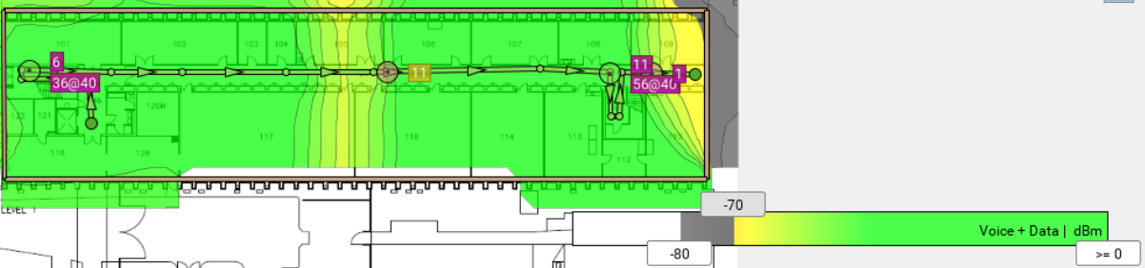

As shown in the above image, the maximum signal coverage is obtained when the signal strength is present between the range -70dbm to 0dbm. Though there was a slight downfall of the signal coverage, the entire level has portrayed an average signal strength of -46dbm, which was meeting the requirements.

Signal to Noise Ratio

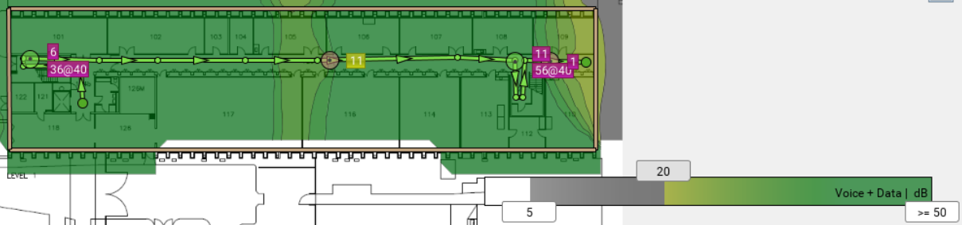

The minimum SNR is been set to 20db, and maximum SNR is set to 50db. The areas in this level have possessed greater signal-to-noise ratio whereas the corner most part of this level has shown more noise when compared to the signal level.

Throughput

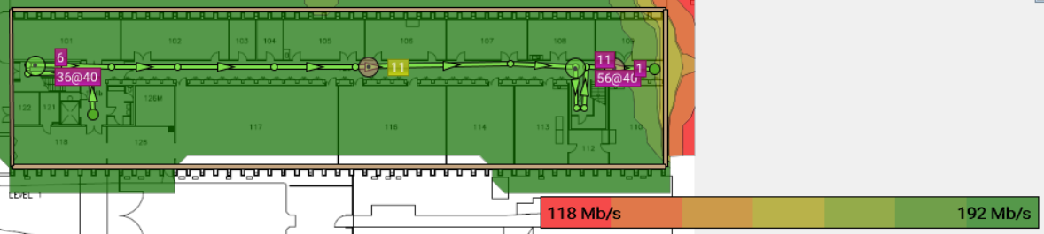

The heatmap is showing the throughput obtained at every point in this level. The maximum throughput is obtained was calculated at an average of 188-192 Mb/s. We have observed that the devices operating on 2.4GHz have received enough throughput throughout the level. Also, the minimum throughput obtained in this level was ranging from 118-122 Mb/s.

Interference difference

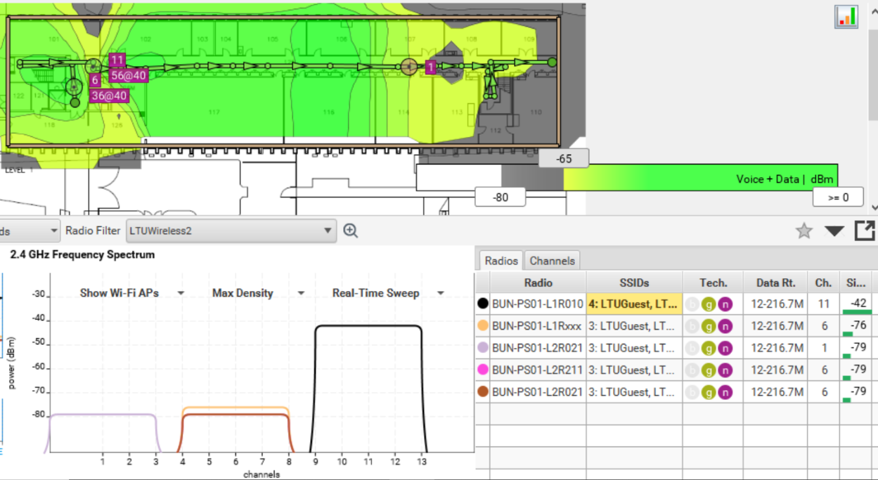

From the above graphs, we can see that only one access point is working on channel 11 with the maximum signal strength of -42dbm without any interference of other channel.

For 5GHz:

Signal strength

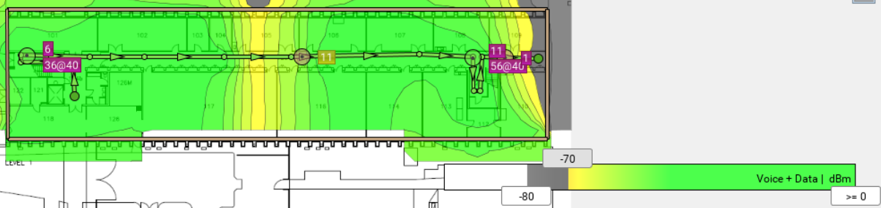

The above heatmap is showing the signal level when connected to 5GHz band. Compared to the result obtained with 2.4GHz, this level has shown less signal strength as the devices connected with 5GHz bandwidth can connect within smaller ranges. We can also observe that the area has poor or weak signal coverage at the corner, which has fallen to -80bdm, and the maximum signal level was obtained mainly near the access points.

Signal to Noise Ratio

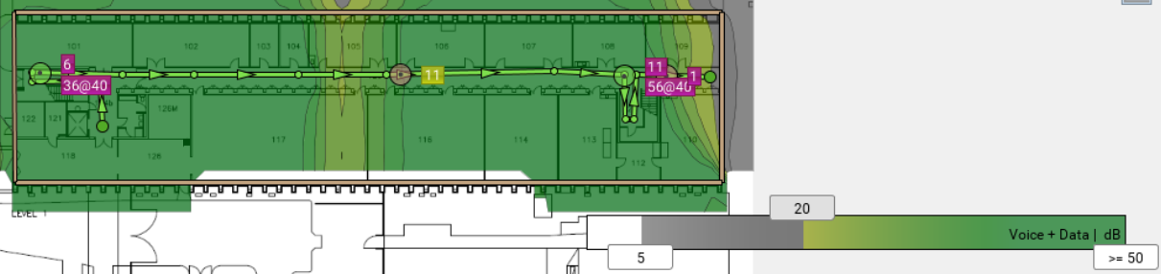

The maximum and minimum SNR values are set to 50db and 20db, respectively. The area covered with dark green shows the maximum signal level, and the area covered with grey color represent that there is much noise present in that area.

Throughput

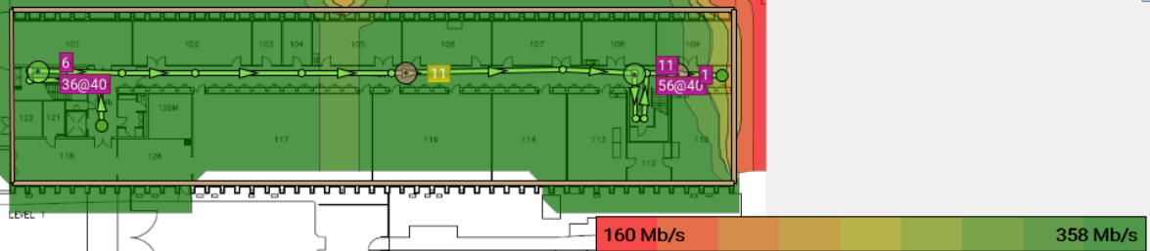

In this level, the maximum throughput was obtained from the range of 352-258 Mb/s, and the minimum throughput obtained was 160 Mb/s indicating good data transmission between the devices. The overall throughput obtained was good as all the devices can operate with 5GHz band as well.

Interference difference

We could not find any interference in the channels when connected in 5GHz since we have specified just one SSID.

Level-2

For 2.4GHz

Signal strength

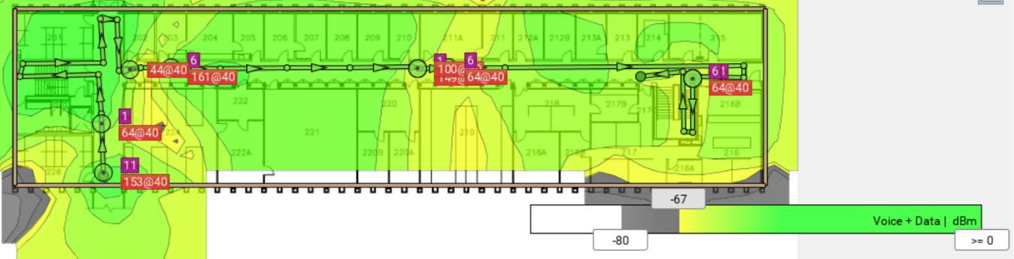

As shown in the diagram, the maximum signal coverage is obtained with the frequency of -67dbm. We observed that the good signal strength was obtained near the access points in this level. As we can see that the area which is closer to the staircase is possessing less signal coverage, which might need to be improvised in terms of signal coverage.

Signal to Noise Ratio

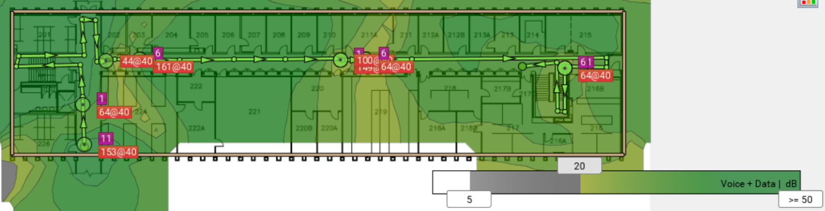

The minimum SNR has been set to 20db, and maximum SNR is evaluated as 50db. The area covered with pale green is showing the less signal level, and we also observed that the noise interference in this level seems to be less when operated in 2.4GHz band.

Throughput

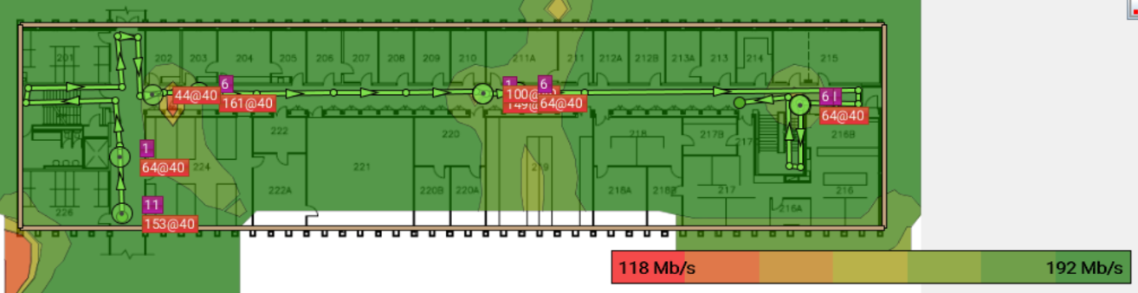

In this level, the maximum throughput gain obtained was around 190-192Mb/s, and the minimum throughput was obtained around 118Mb/s. From the heatmap, we observed that there is great throughput data transfer with respect to 2.4GHz in this level.

Interference difference

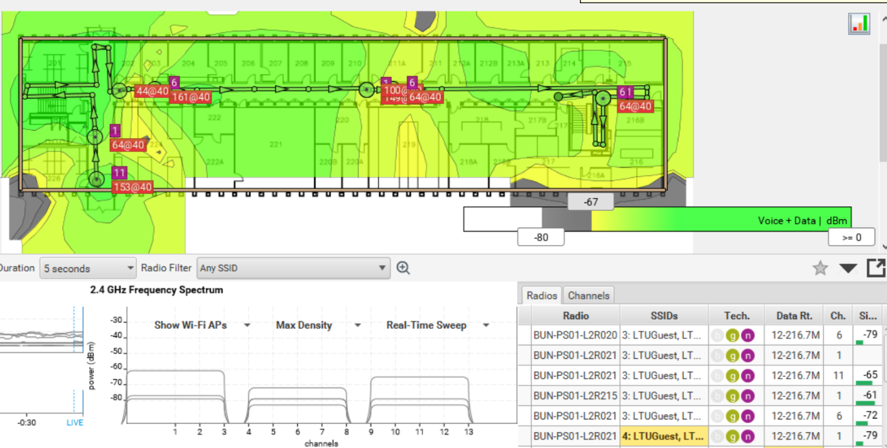

From the graph, we can see that all the access points are working on channels 1, 6, 11 respectively. So there is less possibilities of interference. For 5GHz:

Signal strength

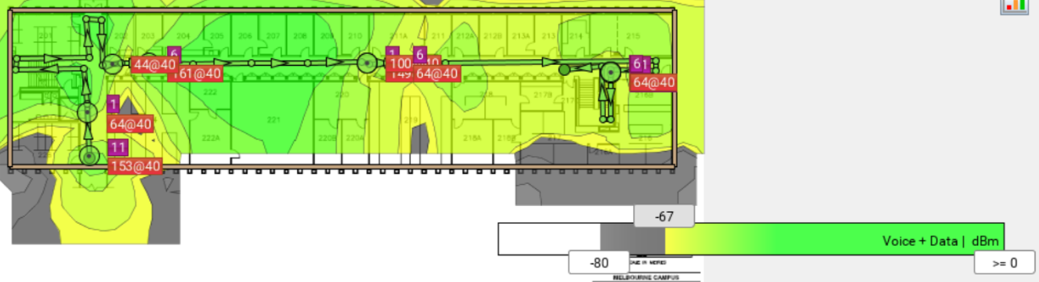

This heatmap shows the signal strength when connected to 5GHz, where the maximum signal strength was obtained with regards to the threshold of -67dbm. This helped in covering the entire level in 5GHz band. There are areas with poor signal strength indicated by grey colour where the signal dropped at -80dbm.

Signal to Noise Ratio

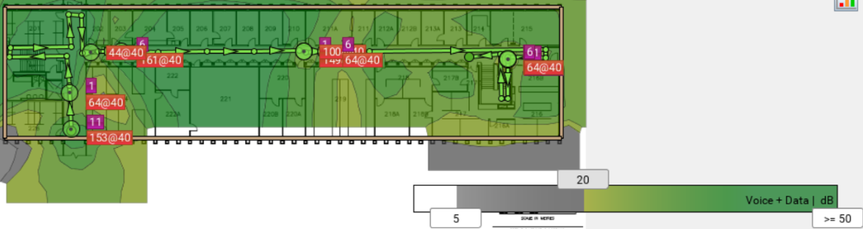

The above heatmap is portraying SNR for 5GHz, where the maximum value is set to 50db, and the minimum value is set to 20db. There are few areas in this level where the signal level is more than the noise level.

Throughput

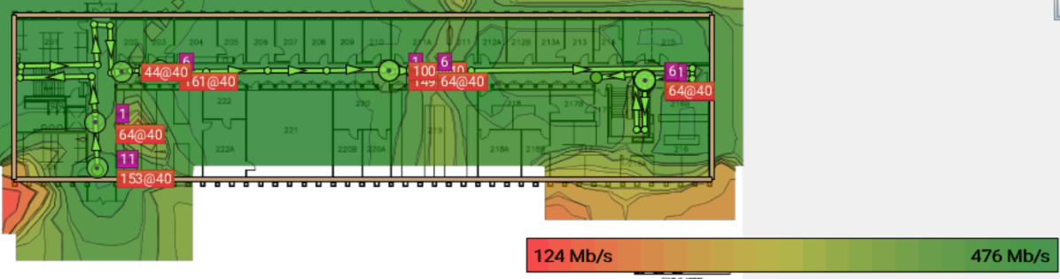

In this heatmap, the maximum throughput obtained was from 470-476 Mb/s, and the minimum throughput obtained was 122 to 124 Mb/s. We could hardly observe the areas with less throughput.

Level-3

For 2.4GHz

Signal strength

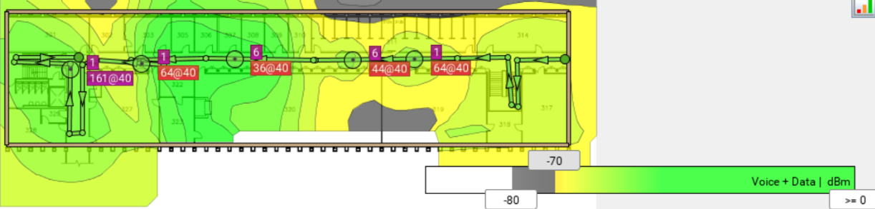

The maximum signal strength was obtained at -45dbm, and the minimum signal strength was obtained at -70dbm. The area with grey color depicts that the area possesses poor signal with frequency of -80dbm. The rooms 319 and 320 are the rooms where there is poor signal coverage partially. Overall signal strength was good in this level when operated in 2.4GHz band.

Signal to Noise Ratio

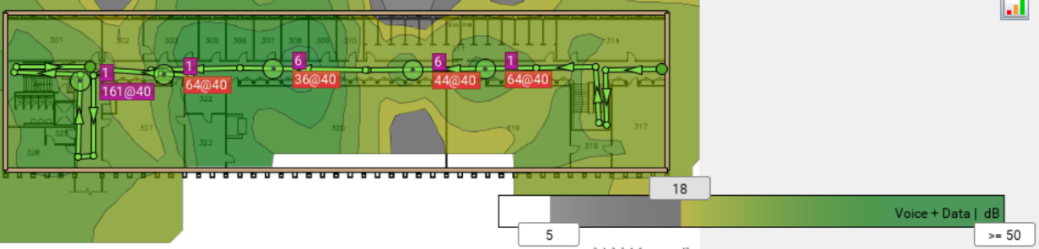

The maximum signal level is set to 50db, and the minimum signal level is obtained at 18db, and the noise level is detected at 5db. We could observe the room 320 has partial noise, which may cause the interference to the radio frequency spectrum.

Throughput

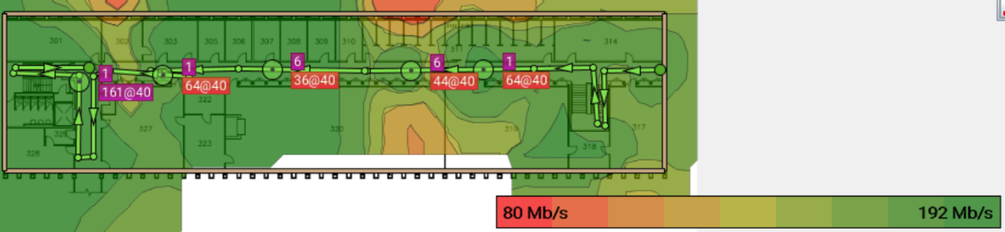

The above heatmap shows the throughput when operating in 2.4 GHz, where the maximum data transfer is obtained 190-192 Mb/s, and the minimum throughput was obtained around 80 Mb/s. The overall throughput obtained in this level has indicated that all devices connected 2.4GHz can communicate with each other with less data loss.

Interference difference

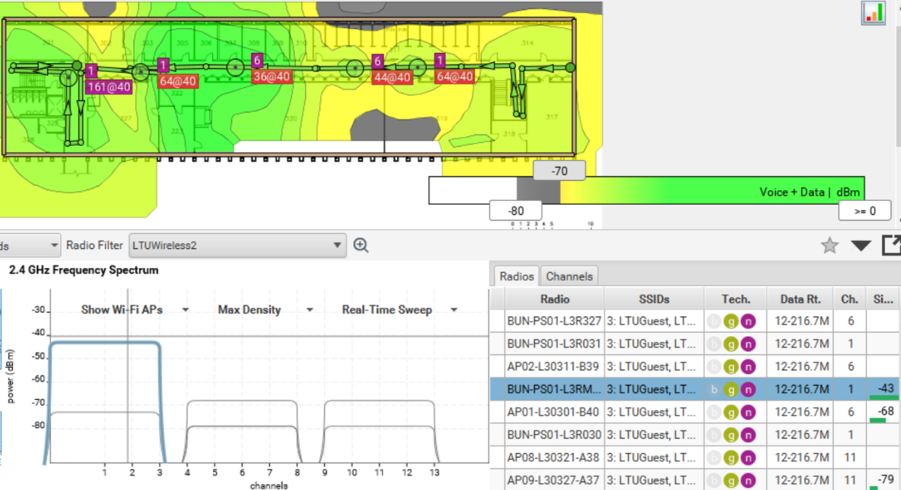

For 5GHz:

Signal strength

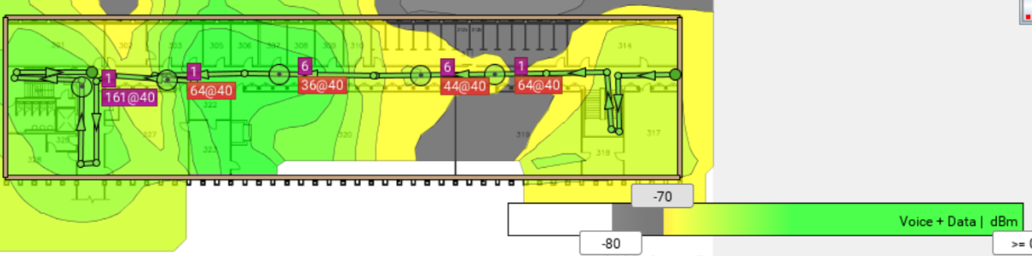

As we can see that the signal strength obtained in this level is less when compared to 2.4GHz spectrum. The maximum signal coverage is obtained from 0 to -70dbm, and the poor signal coverage area is indicated with grey color which means that the signal power is -80dbm.

Signal to Noise Ratio

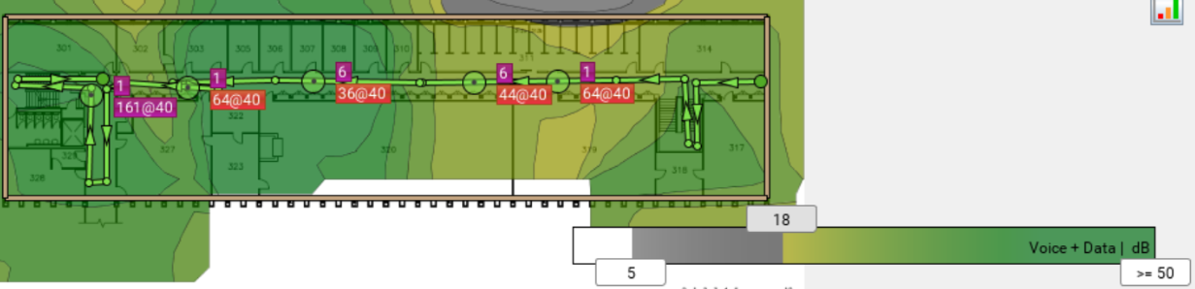

The above heatmap is portraying the SNR in which is set between 50db and 18db, which are maximum and minimum, respectively. When operated in 5GHz, the noise that we have observed in 2.4GHz bandwidth was slightly reduced possessing good signal strength in this level.

Throughput

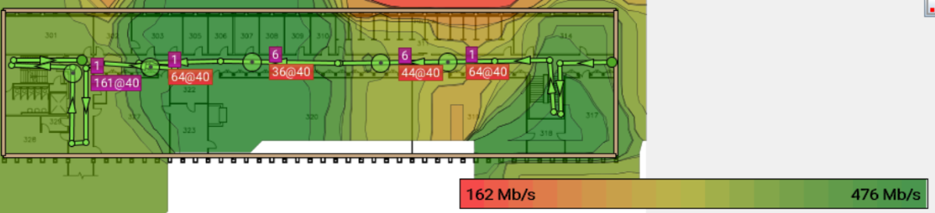

The throughput in this level is obtained as the maximum of 476 Mb/s and the minimum throughput of 160-162Mb/s. The areas that are slightly covered with reddish-green are considered to have less throughput, where the devices could hardly communicate with each other.

Level-4

For 2.4GHz

Signal strength

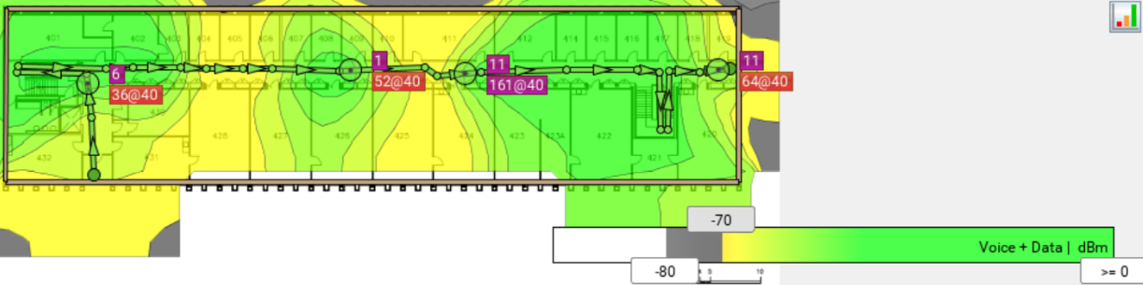

This heatmap shows the signal strength in level-4 when connected to 2.4GHz band. Almost all areas in this level possess good signal strength. The maximum to signal strength was obtained from 0 to -67dbm, respectively. The areas with the access points have possessed good signal strength and the areas where the access points are not present indicated less signal strength.

Signal to Noise Ratio

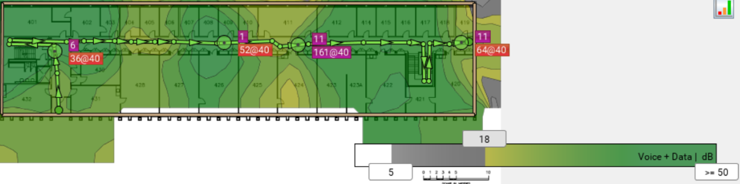

The above diagram shows the SNR when operated in 2.4Hz band. The maximum signal to noise ratio is set to 50db portrayed with dark green, and the minimum signal to noise ratio is set to 18db portrayed with pale green. Almost every corner of this level has possessed good signal levels omitting the noise interferences.

Throughput

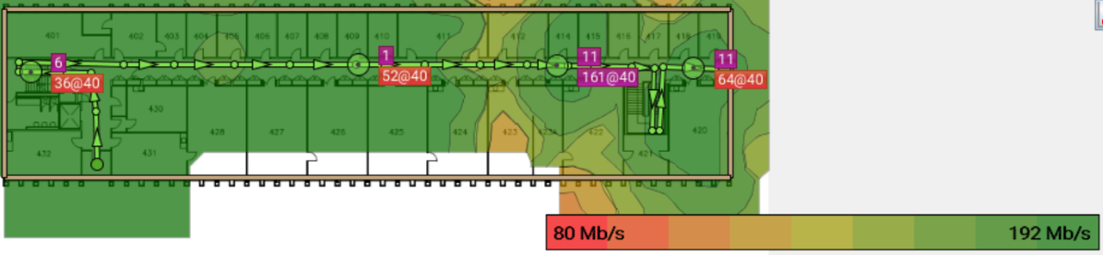

The throughput obtained in 2.4GHz is shown from the above diagram. The highest throughput is obtained form 188-192Mb/s, and the lowest throughput is obtained around 80Mb/s. We observed that the devices operating with 2.4Ghz are supposed to have good data speed throughout the floor.

Interference difference



From the graph, we can see that the access point channel 1 with signal strength -43dbm is being interfered with other access point communicating with same channel, which may cause an interference.

For 5GHz:

Signal strength

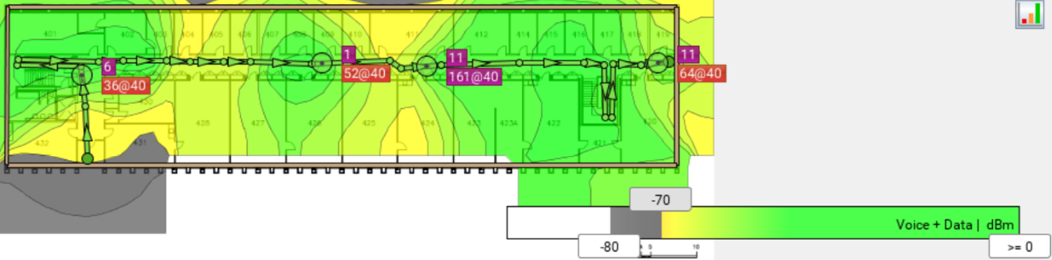

The above heatmap is portraying the signal strength operating in 5GHz band. The minimum signal strength obtained is -70dbm, which is represented with yellowish-green in color. The weak signal of -80dbm or more is indicated with grey color and is observed to have less coverage. However, 5Ghz band is suitable for devices in shorter ranges, and hence there is a chance of poor signal strength in this level.

Signal to Noise Ratio

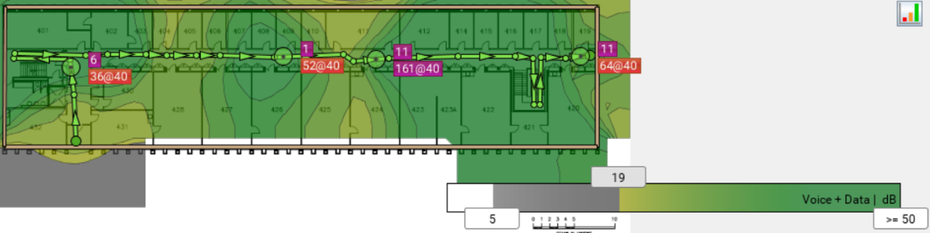

The maximum signal-to-noise ratio is set to 19db and 50db, respectively. In this level, we could hardly find the noise waves that are interfering the radio frequency waves. The areas with pale green are indicated as the areas where there is slight interference in the spectrum. The signal level obtained is more than the noise level, and there be less causes of interferences in this level.

Throughput

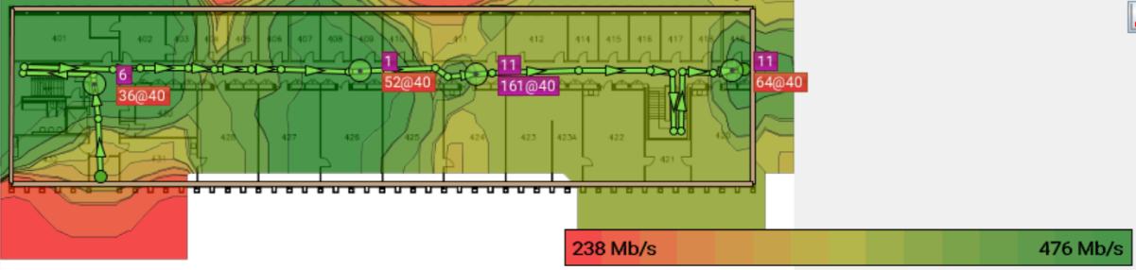

The above heatmap shows the throughput obtained in 5GHz band. The area possesses the maximum throughput of 470-476Mb/s. When operated in 5GHz, it is observed that the data transfer between the devices is seemed to be less. This can be improved by changing the channel of the access point to obtain the maximum throughput.

**10.Problems and their proposed solution:**

Level 1 –

There are few areas in this level where there is much noise caused by the power generator rooms, which may cause interference.

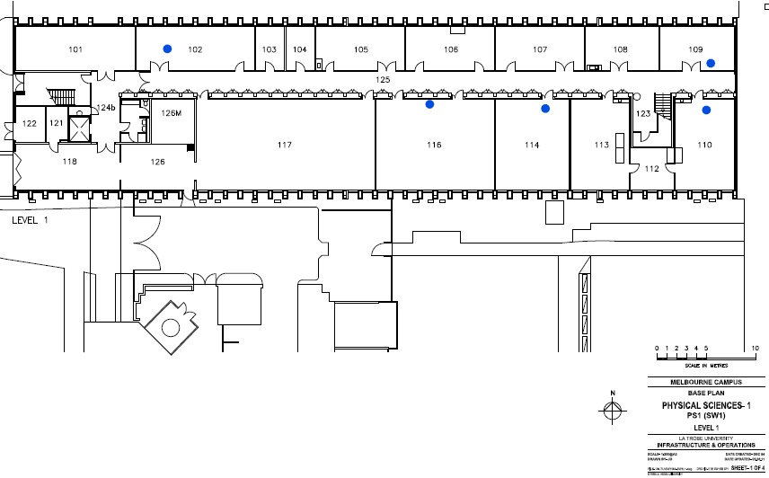

As marked in the above map, those are the points where there is occurrence of noise.

Level 2 –

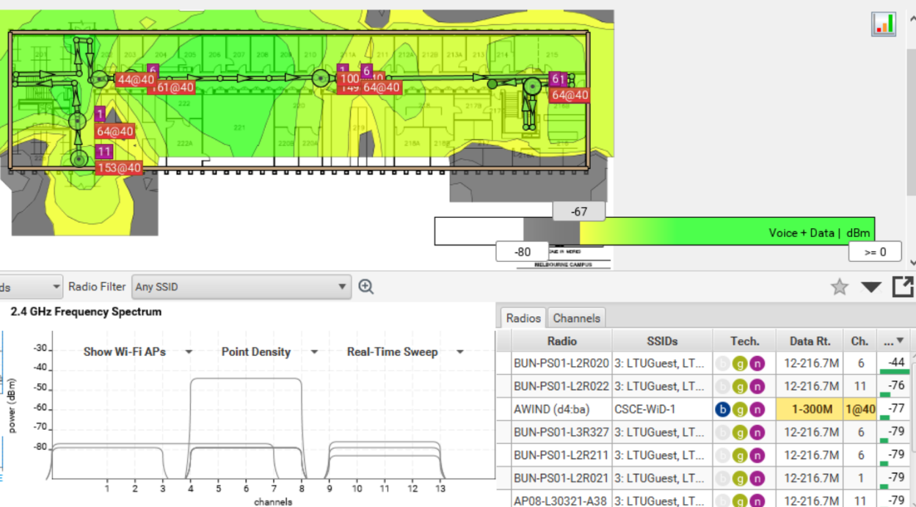

Adjacent channel interference

Two access points are working on same channel (one with channel one and another with channel 11). When operated in 2.4GHz, there is no interference. But when operated in 5GHz, there is an occurrence of adjacent channel interference.

Level 3 – channel change

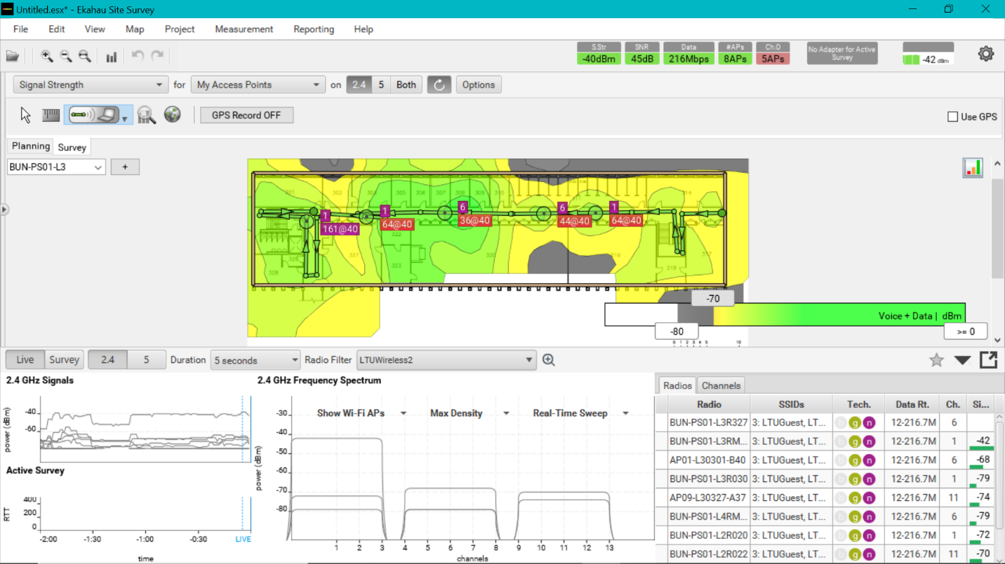

In level-3, an access point with signal strength -42dbm working on channel one is being interfered by another access point with signal strength -79dbm working on same channel.

Solution: by configuring the channel of the second access point by changing from channel 1 to channel 6, the above problem can be eliminated.

Level4 – There are no issues with level 4 while conducting the survey.

**11. Billing Materials:**

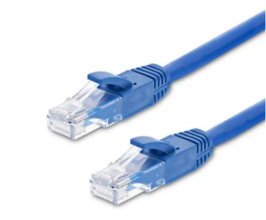 

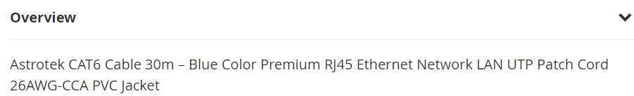

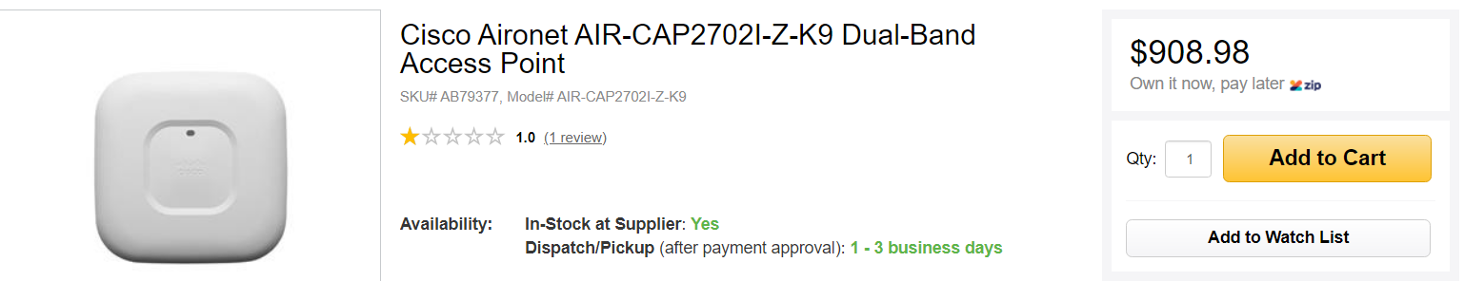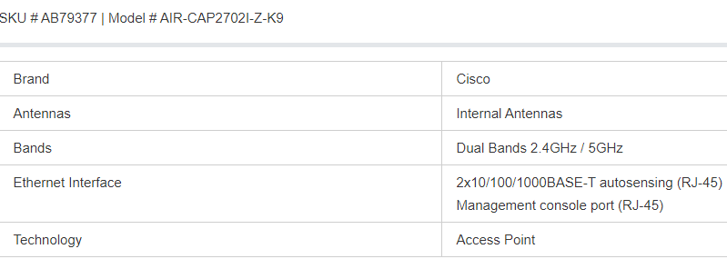

**12.costing:**

|  |  |  |  |
| --- | --- | --- | --- |
| **S.no** | **Components** | **Quantity** | **Total cost** |
| **1** | **Cables** | **4* 23.24** | **92.96 AUD** |
| **2** | **Cisco access point** | **1*908.98** | **908.98 AUD** |
| **3** | **Network Engineer** | **3people working for 5 hours a week** | **6000 AUD** |
|  | **Total** |  | **7001.94 AUD** |

**13.conclusion :**

As per our survey results, we can say that co-channel interference is the main problem. By using the proposed solution results, we can configure and regulate the network issues that are observed in the heat maps. After configuring, we can check the co-channel interference, signal-noise ratio and the signal strength with the tool and improve the areas in weak signal places.

**References:**

<https://www.dicksmith.com.au/da/buy/astrotek-cat6-cable-30m-blue-color-premium-rj45-ethernet-network-lan-utp-patch-cord-26awg-cca-pvc-jacket-astrotek/>

<https://www.mwave.com.au/product/cisco-aironet-aircap2702izk9-dualband-access-point-ab79377#detailTabs=tabSpecifications>

<https://au.indeed.com/salaries/network-administrator-Salaries>

<https://www.ekahau.com/>

<https://www.metageek.com/training/resources/wifi-signal-strength-basics.html>